A Comparative Study of Image Transformations and Machine Learning Models for Eye Disease Prediction

**Sushma Vispute, K Rajeshwari, Atharva Suryawanshi, Yash Rade and Aditi Takale**

Department of Computer Engineering, PCCOE, Pune

***Abstract*— This research paper presents a comparative analysis of image preprocessing techniques and machine learning models for eye disease prediction. The study evaluates the performance of five different models, namely CNN, SVM, KNN, Adaboost, and XGBoost, on four sets of pre-processed images: normal images, LAB+HSV images, LAB + CLAHECC images, and HSV + Gabor images. The findings underscore the importance of selecting appropriate preprocessing techniques and machine learning models for accurate eye disease prediction. For the set of pre-processed images utilizing HSV + Gabor transformations, the CNN model demonstrated the highest accuracy of 89%. This research contributes to advancing the understanding of effective methodologies for medical image analysis and underscores the significance of leveraging machine learning in healthcare applications.**

***Keywords*—image preprocessing, machine learning, eye disease prediction, CNN, SVM, KNN, Adaboost, XGBoost, LAB, HSV, CLAHECC, Gabor transformation.**

# **I. Introduction**

Eye disease prediction plays a pivotal role in healthcare, facilitating early diagnosis and intervention, ultimately improving patient outcomes, especially in conditions such as choroidal neovascularization (CNV), drusen, and diabetic macular edema (DME) [3] [6]. Leveraging machine learning algorithms tailored for this purpose is crucial in enhancing diagnostic accuracy and guiding clinical decision-making [4].

The journey commences with the collection and preprocessing of extensive historical image data related to CNV, drusen, and DME [3]. This involves addressing challenges such as noise reduction, contrast enhancement, and feature extraction specific to these diseases [3] [4] [6]. Python's versatile libraries, particularly XGBoost and Random Forest, serve as indispensable tools in training robust prediction models capable of accurately diagnosing CNV, drusen, and DME [5].

Model evaluation becomes paramount in guiding risk assessment and decision-making processes in the context of these diseases [4]. Metrics such as accuracy, precision, and recall are scrutinized to assess the performance of machine learning models in predicting CNV, drusen, and DME [4]. Comparative analysis is conducted among prominent algorithms including CNN, SVM, KNN, Adaboost, and XGBoost, to discern their efficacy in predicting these specific eye diseases [4] [5] [6].

Moreover, visualization techniques such as histograms are employed to elucidate data patterns and aid in model selection and refinement for CNV, drusen, and DME prediction [5]. By harnessing advanced algorithms and visualization methodologies, this research endeavors to enhance risk management strategies and provide valuable insights for clinical practitioners in addressing these prevalent eye diseases [4]. Ongoing research in this domain aims to further refine prediction models, ultimately advancing the field of medical image analysis and improving patient care in the realm of ophthalmology [3] [6].

**II. Literature Review**

“An Expert System to Predict Eye Disorder Using Deep Convolutional Neural Network”, by M. R. Ahmed, S. R. Ahmed, A. D. Duru, O. N. Uçan, and O. Bayat. The authors developed an expert system using a Deep Convolutional Neural Network (DCNN) to accurately detect glaucoma, achieving a high accuracy rate of 92.78% with efficient processing time, demonstrating the effectiveness of DCNN in eye disease diagnosis without the need for multiple models[1].

“Eye Disease Classification Using Deep Learning Techniques” by Babaqi, Tareq, et al. The authors highlight the importance of eye health and the potential of deep learning and image processing in disease detection. They utilized CNN and transfer learning to improve the classification of cataracts, diabetic retinopathy, and glaucoma. The study suggests that transfer learning significantly enhances CNN's performance in detecting eye diseases, and they plan to explore its efficacy further with a diverse dataset and other disease detection tasks in future research[2].

"A deep learning algorithm for prediction of age-related eye disease study severity scale for age-related macular degeneration from color fundus photography." Grassmann, Felix, et al. The authors demonstrate that their deep learning algorithm outperforms human graders in identifying AMD from fundus images, showing high accuracy and reliability, especially in populations over 55 years old and when certain conditions are met for data preprocessing[3].

“Eye Disease Detection using Machine Learning.”, Shaikh, Fiza et al. The authors developed a machine learning project to detect eye diseases, categorizing images into normal, glaucoma, and retinopathy groups using a CNN model. This approach aims to improve the automation, specificity, and sensitivity in diagnosing glaucoma and retinal diseases, leveraging advanced machine learning techniques for efficient disease detection and analysis[4].

“Eye Disease Detection Using Machine Learning.”, Ramanathan, Gauri et al. The authors propose a system to facilitate the early detection of cataract, glaucoma, and retinal diseases using Logistic Regression, Random Forest, Gradient Boosting, and Support Vector Machine algorithms. This system aims to reduce the percentage of blindness by providing timely treatment. They evaluate the effectiveness of cataract surgery in eyes with age-related degeneration and demonstrate the accuracy of the algorithms in classifying fundus images. Gradient Boosting exhibits the highest accuracy of 90% in detecting cataract, followed by logistic regression (89%) and random forest (86%)[5].

“A Survey on Automated Eye Disease Detection using Computer Vision Based Techniques.”, Vyas, Aditi and Vidhi Khanduja. The authors highlight the significance of recent advancements in AI for objectively identifying eye-related diseases, which greatly impact patients' quality of life. They review machine learning and deep learning techniques for detecting diseases such as ARMD, cataract, DR, and glaucoma, noting that AI-based methods exhibit higher accuracy compared to manual feature extraction and classification techniques across all disease areas[6].

# **III. Theory**

Machine Learning (ML) plays a pivotal role in augmenting the capabilities of Artificial Intelligence (AI) systems by enabling them to learn from real-world interactions and observations. This study delves into the comparative analysis of various image preprocessing techniques and machine learning models for the prediction of eye diseases, a critical domain in healthcare.

## A) Image Processing Techniques

1. Normal Images: These represent raw images devoid of any preprocessing, serving as the baseline for comparison.

2. Lab + HSV Images: Leveraging the Lab color space alongside the Hue, Saturation, and Value (HSV) color space, this technique enriches color information within images.

3. Lab + CLAHE (Contrast Limited Adaptive Histogram Equalization): Employing CLAHE on Lab color space images enhances contrast and sharpens local details.

4. HSV + Gabor Images: Gabor filters applied to HSV color space images enable the capture of intricate texture features

We evaluated the effectiveness of these preprocessing techniques in conjunction with five different machine learning models:

## B) Machine Learning Models

1. Convolutional Neural Network (CNN): Renowned for its prowess in image classification tasks, CNNs learn intricate features directly from pixel values.

2. Support Vector Machine (SVM): A supervised learning algorithm, SVM identifies the optimal hyperplane for class separation in high-dimensional feature spaces.

3. k-Nearest Neighbours (kNN): This non-parametric, instance-based algorithm classifies instances based on similarity to neighbouring instances in the feature space.

4. AdaBoost: An ensemble learning method, AdaBoost combines multiple weak classifiers to construct a robust classifier, focusing on challenging instances for refinement.

5. XGBoost: Known for scalability and efficiency, XGBoost employs gradient boosting algorithms to create an ensemble of weak decision trees, minimizing prediction errors through objective function optimization.

# **IV. Methodology**

## A) Experimental Methodology

The primary objective of our study is to compare the performance of different machine learning models for eye disease prediction using various preprocessing techniques. We perform various transformation on images to highlight the important features that are expected to be learnt by the model as well as reduce the noise from the image for better generalization and overall accuracy.

We then perform basic preprocessing techniques like resizing, normalization, shuffling, etc. With these newly produced set of transformed images, we perform CNN feature extraction by passing the images through the pretrained model VGG, with additional customized dense layer of 2048 neurons for better learning of the data. The extracted features are then passed through each model to get predictions. Fig 1 shows the CNN architecture used for feature extraction.

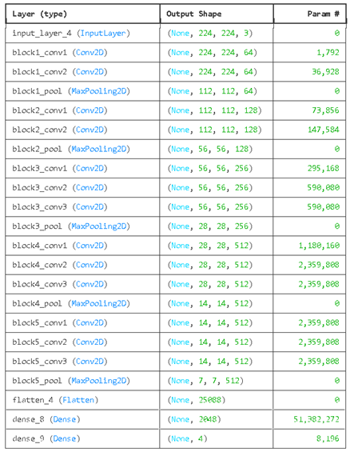

Table 1 CNN Feature Extractor Architecture

## B) Dataset

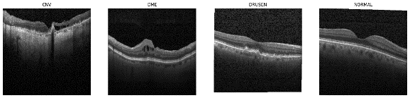 The dataset utilized in this study was obtained from Kaggle, an open-source platform for data science competitions and datasets. This dataset consists of a total of 34,000 color fundus photographs of the eye, captured at resolutions of 512 x 512 pixels and 512 x 496 pixels. The dataset includes a diverse range of eye conditions, which includes:

Figure 2 Gray Scale Images

1. Choroidal Neovascularization (CNV),

2. Diabetic macular Edema (DME),

3. Drusen, and

4. Healthy eye images.

To prepare the dataset for analysis, the images were resized to dimensions of 224 x 224 x 3 pixels and underwent normalization to standardize pixel values. Stratified sampling was employed during partitioning to ensure a representative distribution of eye conditions across the subsets. The dataset is publicly available on Kaggle, allowing for reproducibility and further research in the field.

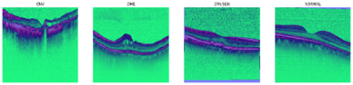

Figure 3 Lab + HSV conversion

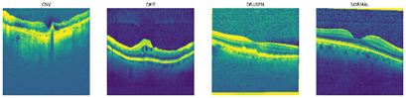

Figure 4 Lab + CLAHECC

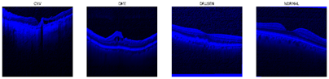

Figure 5 HSV + Gabor Filter

## C) Image Transformation

1. Lab + HSV: Images were converted to LAB and HSV color spaces to extract color information more effectively, enabling better representation of color variations and improving model performance in distinguishing between different eye disease characteristics.

2. Lab + Contrast enhancement (CLAHE+CC): Contrast Limited Adaptive Histogram Equalization (CLAHE) was applied to enhance local contrast in images, followed by color correction to ensure uniform brightness and color consistency across the image, enhancing the visibility of subtle details relevant to eye disease diagnosis.

3. HSV + Gabor filter: Gabor filters were utilized for feature extraction to capture texture information in the images, allowing the model to learn discriminative features related to textural patterns associated with various eye diseases.

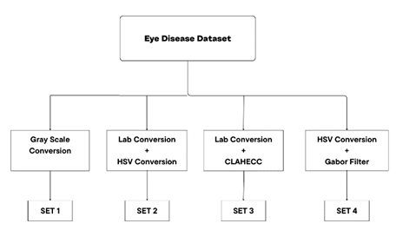

**Image Preprocessing**

Figure 6 Image Preprocessing Flowchart

## D) Machine Learning Models

We implemented 5 machine learning models.

1. Convolutional Neural Network: CNN was chosen as it excels in learning hierarchical representations from image data. It was implemented with appropriate convolutional, pooling, and fully connected layers, followed by SoftMax activation for classification, with hyperparameters tuned through experimentation.

2. Support Vector Machine (SVM): SVM was selected for its effectiveness in binary classification tasks. It was implemented with a radial basis function (RBF) kernel to handle nonlinear data relationships, and regularization parameters were optimized through grid search.

3. K-Nearest Neighbours: kNN was employed due to its simplicity and non-parametric nature.

4. AdaBoost: AdaBoost was chosen for its ability to improve classification performance by combining multiple weak learners. Random Forest was used as base classifiers, and the number of estimators and learning rate were tuned to achieve optimal performance.

5. XGBoost: XGBoost was selected for its efficiency and scalability in handling large datasets. The model was implemented with gradient boosting trees, and hyperparameters such as learning rate, maximum tree depth, and regularization parameters were optimized using cross-validation techniques.

Figure 7 Model Training with Feature Extraction

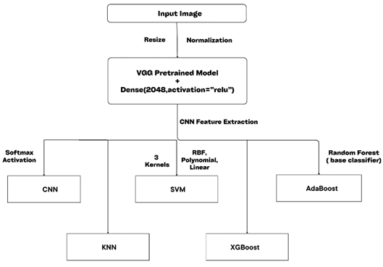

## E) Evaluation Metrics

To assess the predictive efficacy of the machine learning models for eye disease prediction, a range of evaluation metrics was utilized, comprising:

a) Accuracy: The ratio of correctly predicted instances of eye disease.

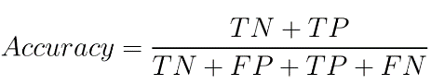

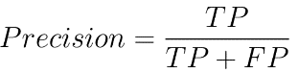b) Precision: The model's capacity to accurately recognize instances of eye disease among the predicted positives.

c) Recall: The proportion of actual cases of eye disease correctly identified by the model.

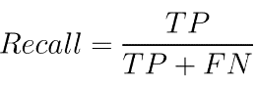

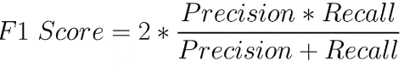d) F1 Score: The harmonic mean of precision and recall, providing a balanced measure of model performance considering both false positives and false negatives.

## **V. Results**

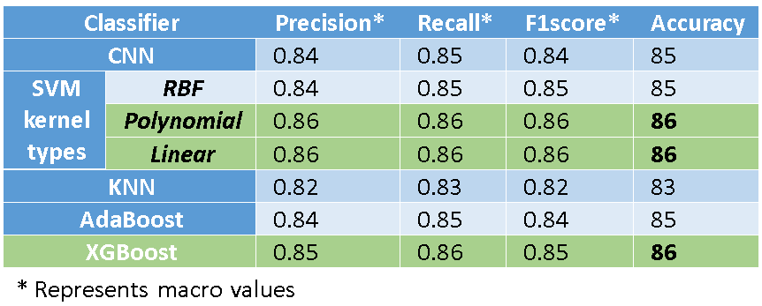

Figure 8 Results of Gray Scale Images

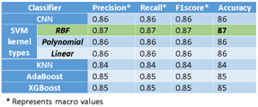

Figure 9 Results of Lab + HSV Images

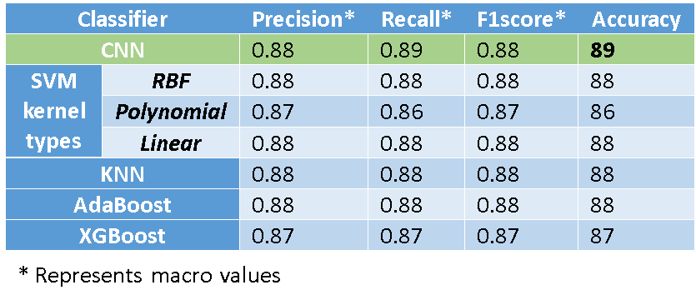

Figure 10 Results of HSV + Gabor Images

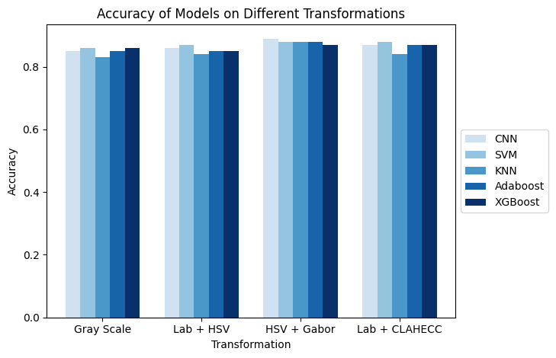

Figure 11 Accuracy

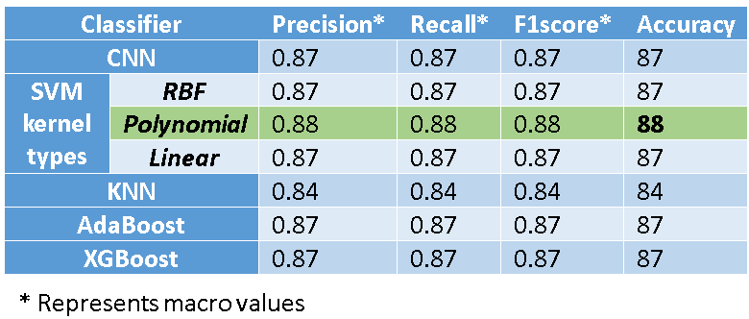

Figure 12 Results of Lab + CLAHECC Images

# **VI. Future Scope**

In future research, delving into advanced image preprocessing and additional feature extraction methods can enhance eye disease detection models. Tailoring novel preprocessing techniques for different eye conditions may unveil hidden patterns, improving model accuracy. Integration of CNNs with attention mechanisms can offer deeper insights into relevant image regions, enhancing prediction accuracy and interpretability. Multimodal data fusion, such as combining images with clinical or genetic data, provides a comprehensive approach to prediction. Furthermore, exploring unsupervised and semi-supervised learning can provide valuable insights into early disease detection, improving clinical decision-making and patient outcomes.

# **VII. Conclusion**

From the comparative analysis conducted on various image preprocessing techniques (Gray scale, Lab + HSV, HSV + Gabor, Lab + CLAHECC) alongside five different classifiers (CNN, SVM with RBF, Polynomial, and Linear kernels, KNN, AdaBoost, and XG Boost), key conclusions emerge. Primarily, CNN consistently demonstrates competitive performance across most preprocessing techniques, achieving high precision, recall, F1-score, and accuracy. Notably, in HSV + Gabor preprocessing, CNN attains the highest accuracy of 89%, underscoring its efficacy in feature extraction for eye disease prediction. Additionally, SVM classifiers, particularly with Polynomial and Linear kernels, exhibit robust performance across various preprocessing methods, maintaining accuracy rates of 86-88%. KNN demonstrates moderate effectiveness with accuracy ranging from 83% to 84%, slightly lower than CNN and SVM. AdaBoost and XGBoost classifiers exhibit stable performance, achieving accuracy rates of 85% to 88% across diverse preprocessing techniques.

Overall, the results emphasize the significance of selecting tailored preprocessing techniques for specific datasets and the efficacy of deep learning approaches, particularly CNN, in extracting discriminative features from eye images for precise disease prediction. Furthermore, transformation of images led to better highlighting of important details as shown in the accuracies of all the models for HSV + Gabor transformed images.

# **VIII. References**

[1]M. R. Ahmed, S. R. Ahmed, A. D. Duru, O. N. Uçan, and O. Bayat, “An Expert System to Predict Eye Disorder Using Deep Convolutional Neural Network”, APJES, vol. 9, no. 1, pp. 47–52, 2021, doi: 10.21541/apjes.741194.

[2] Babaqi, Tareq, et al. "Eye disease classification using deep learning techniques." *arXiv preprint arXiv:2307.10501* (2023).

[3] Grassmann, Felix, et al. "A deep learning algorithm for prediction of age-related eye disease study severity scale for age-related macular degeneration from color fundus photography." *Ophthalmology* 125.9 (2018): 1410-1420.

[4] Shaikh, Fiza et al. “Eye Disease Detection using Machine Learning.” *International Journal of Advanced Research in Science, Communication and Technology* (2022): n. Pag.

[5] Ramanathan, Gauri et al. “Eye Disease Detection Using Machine Learning.” *2021 2nd Global Conference for Advancement in Technology (GCAT)* (2021): 1-5.

[6] Vyas, Aditi and Vidhi Khanduja. “A Survey on Automated Eye Disease Detection using Computer Vision Based Techniques.” *2021 IEEE Pune Section International Conference (PuneCon)* (2021): 1-6.

[7] Bharti, Neha et al. “A Review Paper on Eye Disease Detection and Classification by Machine Learning Techniques.” *Advances in Intelligent Systems and Computing* (2018): n. Pag.

[8] Velásquez, Ricardo Manuel Arias. “A systematic review of machine learning methods for eye illness detection.” *2022 IEEE XXIX International Conference on Electronics, Electrical Engineering and Computing (INTERCON)* (2022): 1-4.